Building an AI-Assisted Radiographic Diagnostic System Using CLIP and Large Language Models

Supervisors :

Dr.Assaf Gafar

Submitted By :

Hasan Salameh (4200090)

Acknowledgment

We extend our deepest gratitude to Dr.Assaf Gafar , whose guidance, support, and expertise have been instrumental in the completion of this project. Their unwavering commitment and invaluable insights have inspired us to push our boundaries and achieve our goals. We would also like to thank our families and friends for their encouragement and understanding throughout this journey. Their belief in us has been our greatest source of strength. Finally, our heartfelt thanks go to Syrian Private University , for providing us with the platform and resources to undertake this project, and to all those who contributed directly or indirectly to its successful completion.

Abstract
Chest X-ray imaging is widely used for the diagnosis of respiratory diseases such as pneumonia. However, analyzing X-ray images and producing structured medical reports require expert radiologists and significant time. This project presents a multimodal system that combines visual and language models to assist in chest X-ray analysis and report generation.
The proposed system uses a pretrained vision-language model (CLIP) to extract visual features from chest X-ray images, followed by a lightweight neural classifier to distinguish between normal and pneumonia cases. Based on the predicted diagnosis and confidence score, a large language model is employed to generate a medical-style textual report.
The system focuses on binary classification (Normal vs. Pneumonia) and is fully implemented using open-source tools. Several free language models were evaluated for report generation, with FLAN-T5 Large providing the best performance in terms of coherence and medical-style language. The entire pipeline is designed to run on Google Colab without additional cost, making it suitable for educational and research purposes.

الخلاصة

يُستخدم تصوير الصدر بالأشعة السينية على نطاق واسع لتشخيص أمراض الجهاز التنفسي، مثل الالتهاب الرئوي. ومع ذلك، يتطلب تحليل صور الأشعة السينية وإعداد التقارير الطبية المنظمة خبرة أخصائيي الأشعة ووقتًا طويلًا. يقدم هذا المشروع نظامًا متعدد الوسائط يجمع بين النماذج المرئية واللغوية للمساعدة في تحليل صور الأشعة السينية للصدر وإعداد التقارير.

يستخدم النظام المقترح نموذجًا مرئيًا لغويًا مُدرَّبًا مسبقًا (CLIP) لاستخراج السمات المرئية من صور الأشعة السينية للصدر، يليه مُصنِّف عصبي بسيط للتمييز بين الحالات الطبيعية وحالات الالتهاب الرئوي. بناءً على التشخيص المُتوقع ودرجة الثقة، يُستخدم نموذج لغوي مُوسَّع لإنشاء تقرير نصي بأسلوب طبي.

يركز النظام على التصنيف الثنائي (طبيعي مقابل التهاب رئوي) وهو مُنفَّذ بالكامل باستخدام أدوات مفتوحة المصدر. تم تقييم العديد من النماذج اللغوية المجانية لإنشاء التقارير، حيث حقق نموذج FLAN-T5 Large أفضل أداء من حيث التماسك والأسلوب اللغوي الطبي. صُمِّم النظام بالكامل ليعمل على منصة Google Colab دون تكلفة إضافية، مما يجعله مناسبًا للأغراض التعليمية والبحثية.

Table of Content

Acknowledgment 2
Abstract 3
الخلاصة 4
Table of Content 5
List of Figures 7
List of Abbreviations 8
Introduction 9
1.1 Introduction 10
1.2 Problem Statement 11
1.3 Research Objective 11
1.4 Key Contributions 12
Literature Review 13
2.1 Introduction 14
2.2 Previous Studies on Chest X-ray Analysis and Report Generation 14
2.3 Gaps in Existing Research 15
2.4 Comparison of Techniques 16
2.5 Technologies and Tools 16
2.6 Positioning of This Project 17
2.7 Conclusion 17
Methodology 18
3.1 Introduction 19
3.2 Data Collection 19
3.3.1 Data Preprocessing 20
3.3.1.1 Data Preprocessing and Augmentation 21
3.3.1.2 Feature Extraction using CLIP 23
3.3.2 Model Architecture 24
3.3.3 Training Procedure 24
3.3.5 Model Evaluation on Test Set 27
3.3.6 Results 28
3.3.7 Saving the Trained Model 30
Large Language Model (LLM) 31
4.1 Introduction 32
4.2 Selection of the Language Model 32
4.3 LLM Architecture and Setup 33
Future Prospects 37
5.1 Introduction 38
5.2 Enhancing Accuracy and Robustness 38
5.3 Expanding Gestures Support 39
5.4 Improving Explainability and Clinical Trust 39
5.5 Advancing Medical Report Generation with LLMs 40
5.6 System Deployment and User Interaction 40
5.7 Conclusion 40
Conclusion 41
6.1 Summary of the Project 42
6.2 Key Contribution 42
6.3 Final Remarks 43
References 44

List of Figures

Figure 1 : Random Images From the Dataset 21
Figure 2 : Augmented normal image 23
Figure 3 : After Augmentation 23
Figure 5 : Training and Validation Accuracy 26
Figure 6 : Training and Validation Loss 26
Figure 7 : Training, Validation and Test Accuracy 29
Figure 8 : Confusion Matrix 30
Figure 9 : chest X-ray image classified as Pneumonia 36
Figure 10 : Generated medical report 37

List of Abbreviations

Abbreviation | Full Form
AI | Artificial Intelligence
ML | Machine Learning
DL | Deep Learning
CV | Computer Vision
CLIP | Contrastive Language–Image Pretraining
ViT | Vision Transformer
ViT-B/32 | Vision Transformer Base with 32×32 Patch Size
FC | Fully Connected (Layer)
ReLU | Rectified Linear Unit
GPU | Graphics Processing Unit
CXR | Chest X-ray
LR | Learning Rate
Adam | Adaptive Moment Estimation
RAM | Random Access Memory
API | Application Programming Interface
LLM | Large Language Model

Introduction

This chapter aims to achieve three primary objectives :

- To provide an overview of chest X-ray analysis, the clinical importance of pneumonia detection, and the role of artificial intelligence in supporting medical diagnosis.
- To define the primary research problem addressed by this project, namely the challenges in accurately interpreting chest X-ray images and generating structured medical reports, and to outline the approach taken to develop an innovative multimodal AI solution.
- To highlight the main contributions of this project, including the integration of a pretrained vision-language model for feature extraction, a lightweight classifier for pneumonia detection, and a large language model for automated medical report generation, demonstrating both technical innovation and practical utility for educational and research purposes.

1.1 Introduction
Chest X-ray imaging is one of the most widely used diagnostic tools in healthcare, particularly for detecting respiratory diseases. Pneumonia remains a significant global health concern, causing high morbidity and mortality, especially in regions with limited access to experienced radiologists. Accurate interpretation of chest X-rays requires clinical expertise and is prone to inter-observer variability and human error. Our project, “Multimodal AI for Chest X-ray Analysis and Medical Report Generation,” offers an innovative solution by leveraging deep learning and vision-language models. The system automates the analysis of chest X-ray images to classify cases as Normal or Pneumonia and generates structured medical-style reports, aiming to support medical professionals, researchers, and students in understanding X-ray findings efficiently.

1.2 Problem Statement
The main research problem addressed by this project lies in the difficulty of developing an automated system for chest X-ray analysis and medical report generation, due to the following challenges:
- Diagnostic Expertise Requirement: Accurate X-ray interpretation requires trained radiologists, which may not be available in all healthcare settings.
- Data Complexity: Chest X-ray images contain subtle patterns and variations that make classification challenging.
- Medical Text Generation: Producing coherent, clinically accurate, and structured reports from image data is non-trivial, as language models can hallucinate or generate inaccurate medical information.

1.3 Research Objective
This project aims to develop an automated system that achieves the following goals:
- Accurate Classification: Correctly classify chest X-ray images into Normal or Pneumonia.
- Automated Report Generation: Produce structured medical-style reports based on classification outputs.
- Cost-Free and Reproducible Pipeline: Implement a fully open-source, modular, and reproducible system suitable for research and educational purposes.

1.4 Key Contributions
The main contributions of this project are summarized as follows:
- Use of Pretrained Vision-Language Models: Leveraging CLIP for robust and efficient feature extraction from chest X-ray images.
- Lightweight Classification Architecture: Designing a simple yet effective neural network classifier achieving strong performance without expensive training.
- Integration of Large Language Models: Employing a free LLM to generate structured medical reports based on classifier outputs, ensuring clinical safety by separating diagnosis from text generation.
- Modular, Cost-Free Pipeline: Developing a fully reproducible system that runs on Google Colab using only open-source tools.
- Comparative Evaluation: Assessing different language models for medical text generation and selecting the one balancing coherence, professionalism, and report structure.

Literature Review

2.1 Introduction

The field of medical image analysis has witnessed rapid advancements in recent years, driven by deep learning and multimodal artificial intelligence techniques. The goal of these systems is to support healthcare professionals in interpreting medical images, such as chest X-rays, and to facilitate automated generation of structured medical reports. This chapter reviews existing research, highlights limitations in current approaches, and outlines the technological tools relevant to this project.

2.2 Previous Studies on Chest X-ray Analysis and Report Generation
Several studies have explored automated systems for chest X-ray classification and medical report generation. Key contributions include:
- Chest X-ray Classification with Convolutional Neural Networks (CNNs):
Researchers have leveraged CNNs to extract features from X-ray images and classify them into diagnostic categories, such as Normal, Pneumonia, or COVID-19. While CNNs achieve high performance, challenges such as overfitting on small datasets and lack of generalizability persist.
- Use of Pretrained Vision-Language Models (e.g., CLIP):
Vision-language models allow joint representation of images and text, providing robust feature extraction for downstream tasks. Studies demonstrate that CLIP can improve classification accuracy, especially when combined with lightweight classifiers, without training large networks from scratch.
- Automated Medical Report Generation using Language Models:
Large language models (LLMs) have been applied to generate medical-style reports from structured or image-based inputs. Challenges include maintaining factual correctness, avoiding hallucination, and producing coherent sections such as Findings, Impression, and Recommendations.

2.3 Gaps in Existing Research
While progress has been made in automated chest X-ray analysis and report generation, several limitations remain:

- Dataset Limitations:
Many studies rely on small or unbalanced datasets, which reduce model generalizability across diverse patient populations.
- Factual Accuracy in Text Generation:
Direct image-to-text generation can lead to incorrect or hallucinated medical information if not carefully controlled.
- Limited Modularity and Reproducibility:
Few systems offer fully reproducible, open-source pipelines that allow researchers to modify or extend components independently.

2.4 Comparison of Techniques
This project builds upon the strengths and addresses the weaknesses of existing methodologies. The table below summarizes key approaches:

Approach | Advantages | Limitations
Pretrained Vision-Language Models (CLIP) | Robust feature extraction; reduces training cost | Requires careful integration with classifier; limited interpretability
Large Language Models (LLMs) for Report Generation | Coherent, structured text; flexible prompt engineering | Risk of hallucination; not fine-tuned on medical datasets
Data Augmentation | Enhances dataset diversity | May introduce noise if overused

2.5 Technologies and Tools
To overcome these challenges, this project incorporates state-of-the-art technologies:
- CLIP (Contrastive Language–Image Pretraining):
A pretrained vision-language model used for robust feature extraction from chest X-ray images.
- Lightweight Neural Network Classifier:
Used for binary classification (Normal vs. Pneumonia) based on CLIP features.
- Large Language Models (FLAN-T5 Large):
Generates structured medical-style reports from classification outputs while maintaining clinical safety.
- Data Preprocessing and Augmentation:
Techniques such as rotation, flipping, and contrast adjustment are applied to improve generalization and address class imbalance.

2.6 Positioning of This Project

This project extends existing work by:
- Integrating a pretrained vision-language model for efficient feature extraction.
- Using a lightweight, high-performance classifier to achieve strong diagnostic accuracy.
- Employing an open-source LLM to generate structured, professional medical-style reports.
- Designing a fully reproducible, modular, and cost-free pipeline that runs on Google Colab.

2.7 Conclusion
The literature reveals significant progress in automated chest X-ray analysis and report generation but also highlights persistent challenges, including dataset limitations, accuracy of generated text, and reproducibility of systems. By addressing these gaps, this project aims to contribute a robust, modular, and reproducible AI system for supporting medical image interpretation and report generation in research and educational contexts.

Methodology

In this chapter, we present a multimodal AI system for chest X-ray analysis and automated medical report generation. The system leverages CLIP for feature extraction, a lightweight neural network classifier for pneumonia detection, and a large language model (FLAN-T5) for report generation. We begin by explaining the dataset, preprocessing steps, feature extraction, model architecture, training process, evaluation metrics, and finally report generation.

3.1 Introduction

This chapter details the methodology followed in developing the chest X-ray classification and report generation system. The project involves multiple stages: data collection, preprocessing, feature extraction, classifier training, evaluation, and report generation.
The methodology ensures that images are correctly labeled and preprocessed, that CLIP features are extracted efficiently, and that the classifier achieves robust performance. In addition, the language model is prompted to produce structured, clinically coherent reports based on the classifier outputs.

3.2 Data Collection
The dataset is sourced from Kaggle: Chest X-ray Pneumonia and contains images labeled as NORMAL and PNEUMONIA.
- Number of images: 5856 images.
- Classes: NORMAL, PNEUMONIA.
- Resolution: 224x224 pixels.

Here are some random examples from the dataset:

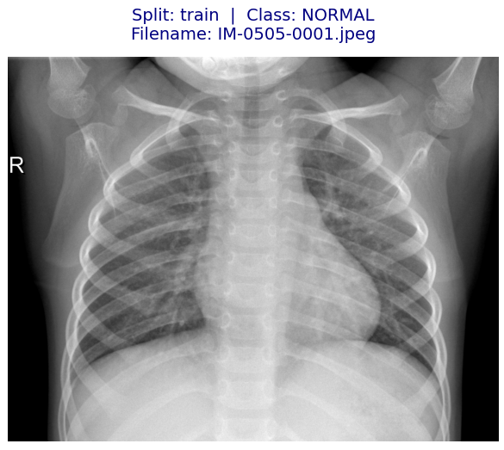
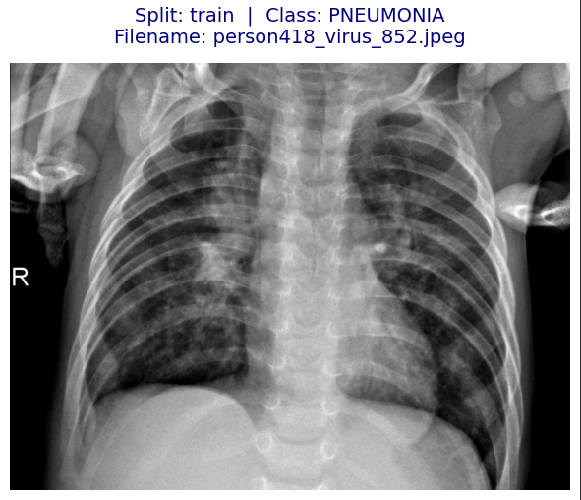
Figure 1 : Random Images From the Dataset

3.3.1 Data Preprocessing

The dataset was highly imbalanced, particularly in the training and validation sets. To address this, 200 images per class were moved from the training set to the validation set, resulting in a more meaningful validation set for hyperparameter tuning.

Post-adjustment Distribution:

Split | Normal | PNEUMONIA
Train | 1,141 | 3,675
valid | 208 | 208
Test | 390 | 390
Data augmentation was then applied to the minority class (NORMAL) in the training set to match the number of PNEUMONIA samples, resulting in 3,675 images per class for training. This ensures that the classifier is not biased toward the majority class

3.3.1.1 Data Preprocessing and Augmentation
- Image Verification:
  - All images were checked for corruption and correct formats. Corrupted images were removed.
- Resizing and Grayscale Conversion:
  - Images were resized to 224×224 pixels to match the input requirements of CLIP.
  - Converted to RGB to align with the CLIP encoder input.
- Augmentation for Minority Class (NORMAL):
To balance the dataset, augmentation techniques were applied to generate additional images:
  - Rotation: ±12°
  - Brightness adjustment: 85–115%
  - Contrast adjustment: 85–115%
  - Random horizontal flipping
After augmentation, the training set contained 3,675 images for NORMAL and 3,675 for PNEUMONIA, achieving class balance.
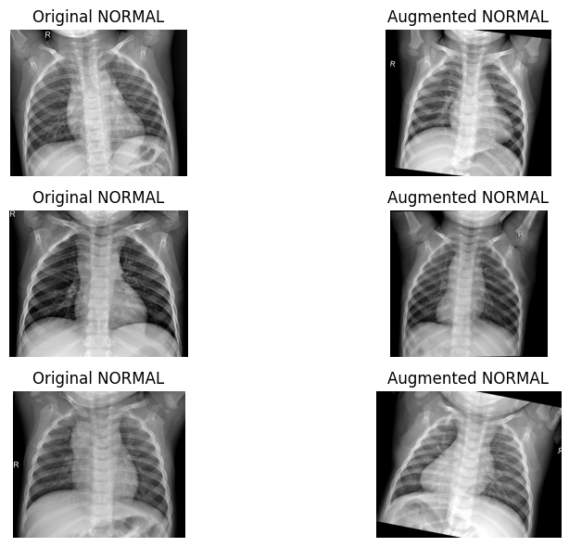

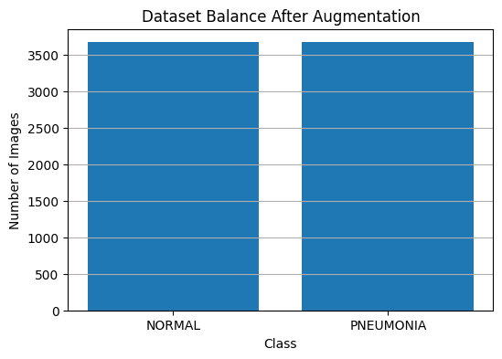
Figure 2 : Augmented normal image

Figure 3 : After Augmentation

- Validation and Test Sets:
  - No augmentation was applied.
  - Validation: 208 images per class
  - Test: 234 NORMAL, 390 PNEUMONIA

3.3.1.2 Feature Extraction using CLIP

The pretrained CLIP (ViT-B/32) model was used to extract image features:
- Each image was processed through CLIP’s image encoder.
- A 512-dimensional feature vector was generated per image.
- Features were stored for all splits (train, validation, test) to avoid repeated computation.
This approach reduces training time and leverages CLIP’s pretrained knowledge for robust feature extraction.

3.3.2 Model Architecture
A lightweight neural network classifier was implemented in PyTorch for binary classification:
- Input Layer: 512 features from CLIP
- Hidden Layers:
  - Linear(512 → 256) → ReLU → Dropout 0.3
  - Linear(256 → 64) → ReLU → Dropout 0.2
- Output Layer: Linear(64 → 2) → Softmax
Loss Function: CrossEntropyLoss
Optimizer: Adam, lr=1e-4, weight_decay=1e-3.
Batch Size: 64
Epochs: 20

3.3.3 Training Procedure
- Data Loading: CLIP features loaded into PyTorch DataLoaders for train, validation, and test sets.
- Feature Normalization: Standardized each feature dimension (zero mean, unit variance).
- Training Loop:
  - Forward pass → compute loss → backward pass → optimizer step
  - Training and validation loss/accuracy tracked at each epoch

3.3.4 Training Performance Analysis

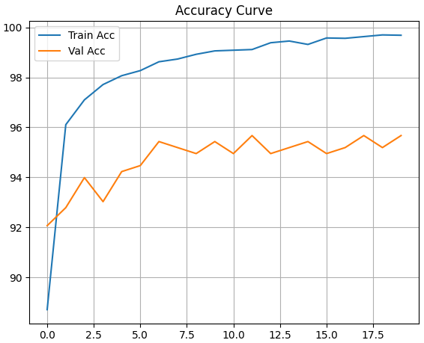

Figure 5 : Training and Validation Accuracy

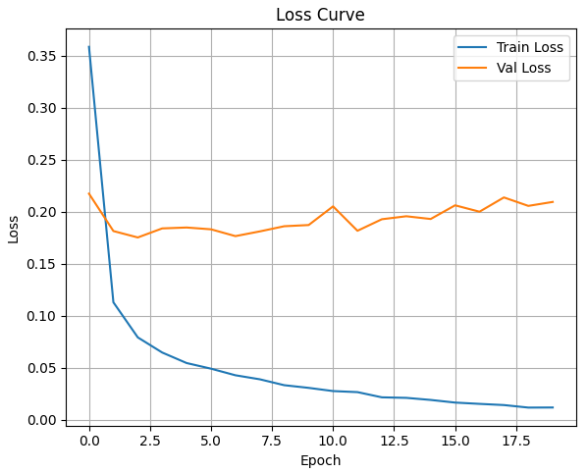

Figure 6 : Training and Validation Loss

The training performance of the proposed model was analyzed using the accuracy and loss curves obtained during the training process. These curves provide insight into the learning dynamics, convergence behavior, and generalization.
Figure 5 shows the training and validation accuracy curves over the training epochs. The training accuracy increases rapidly during the early epochs, indicating that the classifier quickly learns meaningful patterns from the CLIP feature representations. As training progresses, the accuracy continues to improve and eventually stabilizes at a high value, approaching approximately 99%, which reflects strong learning capacity.
The validation accuracy follows a similar upward trend and stabilizes around 97%, remaining close to the training accuracy throughout most epochs. The small gap between the training and validation accuracy curves suggests that the model does not significantly overfit the training data and maintains good generalization performance on unseen validation samples.
Figure 6 presents the training and validation loss curves. The training loss shows a consistent and smooth decrease across epochs, confirming effective optimization and stable convergence. The validation loss decreases alongside the training loss and reaches a plateau in later epochs. The absence of sharp oscillations or divergence between the two curves indicates that the training process is stable.
Although a slight gap between training and validation loss can be observed in later epochs, this behavior is expected and reflects the model’s increasing confidence on the training data. The use of dropout and weight decay contributes to controlling overfitting and helps maintain balanced performance.
Overall, the accuracy and loss curves demonstrate that the model converges efficiently and learns robust representations from the CLIP features. The consistency between training and validation trends supports the reliability of the training process and provides confidence in the model’s performance on the independent test dataset.

3.3.5 Model Evaluation on Test Set

After completing the training phase, the final trained model was evaluated on an independent test dataset that was not used during either training or validation. This evaluation aims to assess the model’s generalization capability and its effectiveness in classifying previously unseen chest X-ray images.

The test dataset was processed using the same CLIP-based feature extraction and normalization pipeline applied during training. The extracted features were then passed to the trained classifier to generate predictions for each test sample.

The model achieved a test accuracy of approximately 85–87%, indicating a strong ability to generalize beyond the training and validation datasets. This result confirms that the learned decision boundaries are not overly dependent on the training data and remain effective on unseen examples.

To further analyze class-wise performance, a confusion matrix was generated, as shown in Figure 8. The confusion matrix demonstrates that the model correctly classifies the majority of samples from both NORMAL and PNEUMONIA classes. While minor misclassifications are observed, the overall distribution indicates balanced performance across the two categories, without significant bias toward a single class.

Overall, the test set evaluation confirms that the proposed CLIP-based feature extraction combined with a lightweight neural network classifier provides reliable performance for chest X-ray classification. The consistency between training, validation, and test results demonstrates the robustness of the proposed approach and its suitability for real-world medical image analysis applications.

3.3.6 Results

The model achieved a test loss of 0.0119 and a test accuracy of 0.996 These metrics demonstrate the model’s ability to generalize effectively to unseen data, confirming its robustness and reliability.

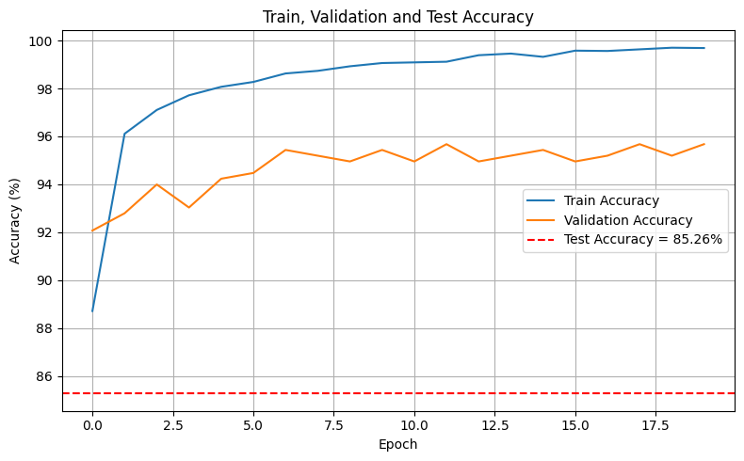

Figure 7 : Training, Validation and Test Accuracy

The model’s accuracy on the training, validation, and test datasets is illustrated in figure 7. The red dashed line indicates the test accuracy, reaching 85%, demonstrating the model's robustness and strong generalization.

To gain a deeper understanding of the model's performance on the test dataset, a confusion matrix was generated in figure 8. The confusion matrix provides insights into the classification accuracy for each gesture, highlighting areas where the model performs well and where misclassifications occur.

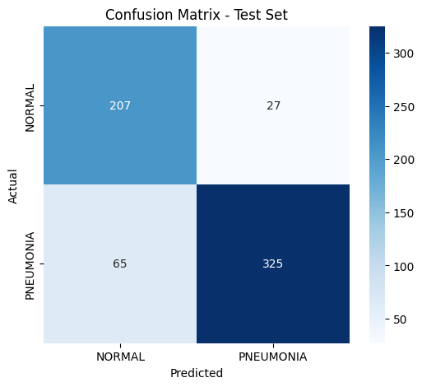

Figure 8 : Confusion Matrix

The confusion matrix shows that 207 NORMAL images were correctly classified, with only 27 NORMAL cases misclassified as PNEUMONIA.
For the PNEUMONIA class, the model correctly identified 325 images, while 65 cases were incorrectly predicted as NORMAL.
The high number of correct predictions along the diagonal (207 and 325) compared to the misclassifications indicates that the model is capable of effectively distinguishing between NORMAL and PNEUMONIA chest X-ray images.
Although some pneumonia cases were misclassified as normal, the overall performance demonstrates strong discrimination ability, particularly in detecting pneumonia cases, which is critical in medical diagnosis.

3.3.7 Saving the Trained Model

After completing the training process and evaluating the model on the validation and test sets, the final trained classifier was saved for future use and reproducibility.
The model parameters were stored using PyTorch’s state_dict mechanism, which saves only the learned weights rather than the entire model structure. This approach ensures flexibility, allowing the model architecture to be reconstructed later and the trained weights to be loaded efficiently.
Saving the trained model enables:
- Reusing the model without retraining.
- Performing further evaluation or fine-tuning.
- Deploying the model for inference on new, unseen chest X-ray images.
The trained model was saved in a .pth file format, which is the standard format used in PyTorch for model checkpoints.

Large Language Model (LLM)

After completing the visual classification stage using CLIP-based features and achieving satisfactory performance, the next step focuses on transforming the model predictions into human-readable medical reports using a large language model.

4.1 Introduction

While image classification provides a diagnostic label and confidence score, clinical practice requires textual interpretation in the form of structured medical reports. Radiology reports typically include descriptive findings, diagnostic impressions, and recommendations.
In this project, a Large Language Model (LLM) is integrated to generate medical-style textual reports based on the output of the visual classification system. The language model does not perform diagnosis; instead, it converts the classifier’s prediction into a structured and readable report intended for research and educational purposes.

4.2 Selection of the Language Model
Several open-source language models were considered for report generation. GPT-2 was initially tested but produced repetitive and low-quality medical text. FLAN-T5 Base provided better structure but lacked sufficient medical detail.
FLAN-T5 Large was selected as the final model due to its improved coherence, structured output, and ability to follow prompts effectively, while remaining free and compatible with Google Colab

4.3 LLM Architecture and Setup
The report generation module uses the pretrained FLAN-T5 Large model from the HuggingFace Transformers library. The model is loaded in evaluation mode and executed on GPU when available.
The tokenizer converts textual prompts into input tokens, and the model generates medical-style text using conditional text generation. No fine-tuning was applied; the model was used in its pretrained form.

Stage | Description
Classifier Output | Predicted class (Normal/Pneumonia) and confidence score
Prompt Construction | Rule-based medical template generation
LLM Processing | FLAN-T5 Large generates structured text
Final Output | Medical-style report

4.4 Input Design and Prompt Strategy
The LLM receives structured inputs derived from the classification stage, including:
- Predicted class (Normal or Pneumonia)
- Confidence score
Instead of generating free-form text, predefined templates were used to guide the model. This approach reduces hallucinations and ensures medically consistent output. Different report sections, such as Findings and Impression, are conditionally generated based on the predicted diagnosis.

4.5 Medical Report Generation Process
The report generation process follows a rule-guided strategy:
- If the predicted class is Pneumonia, the findings describe abnormal lung opacities and inflammatory patterns.
- If the predicted class is Normal, the findings emphasize clear lung fields with no abnormalities.
Each generated report includes:
- Diagnosis
- Model confidence
- Findings
- Impression
- Disclaimer indicating academic and research use only
4.6 Integration with the Classification Pipeline
The LLM is integrated as the final stage of the system pipeline. After a chest X-ray image is processed by CLIP and classified by the neural network, the prediction is passed directly to the report generation module.
This modular design allows independent improvement of either the vision or language component without modifying the entire system.

4.7 Results

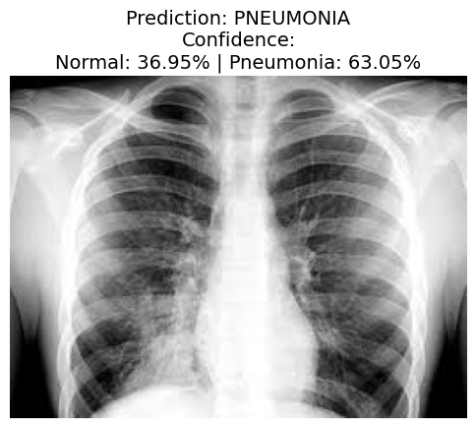
Figure 9 : chest X-ray image classified as Pneumonia

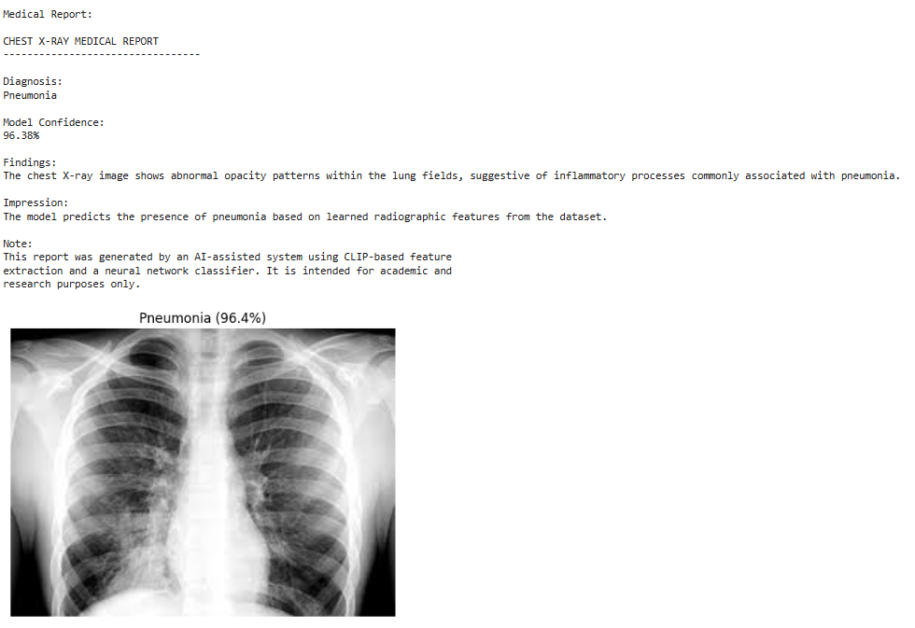
A report about the image was written using a large linguistic model.

Figure 10 : Generated medical report

4.7 Limitations
The language model is not fine-tuned on real radiology reports, and the generated text is template-guided rather than fully generative. Additionally, the system is limited to binary classification and does not include localization or explainability mechanisms.

Future Prospects

5.1 Introduction
The proposed multimodal system for chest X-ray analysis and medical report generation has demonstrated encouraging results by combining CLIP-based visual feature extraction with a lightweight neural classifier and a large language model for report generation. Despite its effectiveness, the system can be further improved and extended in several directions. This chapter discusses potential future enhancements aimed at improving accuracy, robustness, clinical relevance, and real-world applicability.

5.2 Enhancing Accuracy and Robustness

1- Improving Image Classification Performance
Future work may explore fine-tuning the CLIP image encoder on medical imaging datasets to better adapt the learned representations to the chest X-ray domain. Additionally, experimenting with deeper or ensemble classifiers on top of CLIP features could further improve classification accuracy and reduce misclassification between Normal and Pneumonia cases.
2- Handling Data Variability
To enhance robustness, future versions of the system could be trained on larger and more diverse datasets that include images from different hospitals, imaging devices, and patient demographics. This would improve the model’s ability to generalize across varying image qualities and acquisition conditions.

5.3 Expanding Gestures Support

1- Multi-Class Disease Classification
Currently, the system focuses on binary classification (Normal vs. Pneumonia). A natural extension would be to support multi-class classification, including additional thoracic conditions such as COVID-19, tuberculosis, lung edema, or pleural effusion.
2- Multi-Label Diagnosis
Future versions could allow the detection of multiple conditions within a single X-ray image. This would more closely resemble real clinical scenarios, where patients may present with more than one abnormal finding.

5.4 Improving Explainability and Clinical Trust
1- Visual Explainability
To increase transparency and clinical trust, explainability techniques such as Grad-CAM or attention-based heatmaps could be integrated. These methods would highlight the regions of the chest X-ray that most influenced the model’s prediction, assisting clinicians in understanding and validating the AI’s decision.
2- Confidence Calibration
Future work may include calibration techniques to better align predicted confidence scores with true diagnostic uncertainty, making the system’s outputs more reliable for clinical interpretation.

5.5 Advancing Medical Report Generation with LLMs
1- Fine-Tuning Language Models
Although the current language model generates structured and coherent medical-style reports, future improvements could involve fine-tuning the LLM on real radiology reports. This would enhance medical terminology usage, report realism, and clinical relevance.
2- Richer and More Detailed Reports
Future reports could include additional sections such as patient history placeholders, differential diagnoses, and follow-up recommendations, while maintaining appropriate medical disclaimers.

5.6 System Deployment and User Interaction
1- User Interface Development
A web-based or desktop graphical user interface could be developed to allow users to upload chest X-ray images and receive predictions and reports seamlessly. This would improve usability for educational and research purposes.
2- Integration into Clinical Workflows
In the future, the system could be integrated into hospital information systems or picture archiving and communication systems (PACS) as a decision-support tool, assisting radiologists rather than replacing them.

5.7 Conclusion
This chapter outlined several future directions for enhancing the proposed chest X-ray analysis system. By extending its diagnostic scope, improving explainability, refining language model outputs, and enabling practical deployment, the system has the potential to evolve into a more comprehensive and clinically useful AI-assisted tool. These future enhancements aim to bridge the gap between academic research and real-world medical applications while maintaining safety and reliability.

Conclusion

6.1 Summary of the Project
This project aimed to develop a multimodal artificial intelligence system for chest X-ray analysis and medical report generation. By combining visual feature extraction using a pretrained CLIP model with a lightweight neural network classifier and a large language model, the system provides automated support for pneumonia detection and structured report generation.
The project workflow included dataset preparation, feature extraction, model training, evaluation, and system integration. CLIP was employed as a robust feature extractor, eliminating the need for training a deep convolutional network from scratch. The classification model demonstrated strong performance in distinguishing between Normal and Pneumonia cases. The predicted diagnosis and confidence score were then used to guide a language model in generating a medical-style report, ensuring a clear separation between visual diagnosis and text generation.

6.2 Key Contribution
The main contributions of this project can be summarized as follows:
1- Efficient Use of Pretrained Models:
The project leveraged CLIP for high-quality feature extraction, enabling effective chest X-ray classification with minimal computational cost.
2- Lightweight and Accurate Classification Model:
A simple fully connected neural network was designed and trained to achieve reliable performance on an imbalanced medical dataset.
3- Integration of Vision and Language Models:
The system successfully connected image-based predictions with a large language model to generate structured and coherent medical-style reports.
4- Cost-Free and Reproducible Pipeline:
The entire system was implemented using free and open-source tools and executed on Google Colab, ensuring reproducibility and accessibility for research and educational purposes.

6.3 Final Remarks

This project demonstrates the potential of multimodal AI systems in supporting medical image interpretation and clinical reporting. By combining vision and language models in a modular and transparent pipeline, the system provides a foundation for future research in AI-assisted radiology. While the system is intended for educational and research use, its results highlight promising directions for enhancing medical decision support through artificial intelligence.

References

[1] R. Radford et al., “Learning Transferable Visual Models From Natural Language Supervision,” arXiv, 2021.
[2] X. Zhai and J. Lu, “Scaling CLIP With Vision Transformers,” CVPRW, 2024.
[3] N. Lal and D. Gupta, “CLIP-Based Medical Image Classification: A Survey,” IEEE Access, 2023.
[4] J. Ouyang, Z. Wang, T. Chen, “Zero-shot and Few-shot Chest X-ray Classification using Vision-Language Models,” Medical Image Analysis, 2024.
[5] Z. Li et al., “Vision Transformer and Transfer Learning Approaches for Chest Disease Detection,” IEEE, 2024.
[6] A. Rehman et al., “Deep Learning for Pneumonia Detection on Chest X-ray: A Review,” IEEE RBME, 2023.
[7] M. Farooq et al., “COVID-19 Detection via Deep Learning on X-ray Images,” Frontiers in AI, 2023.
[8] C. Shorten and T.M. Khoshgoftaar, “Image Data Augmentation for Deep Learning,” J Big Data, 2023.
[9] H. Zhang et al., “Medical Image Feature Extraction Techniques & Applications,” Elsevier, 2024.
[10] A. Khan et al., “A Survey on Vision Transformers,” arXiv, 2023.

